**LAB TASKS**

**Exercise # 1**

Design 2*2 Bit Binary Multiplier Circuit in Logisim/Logic Works

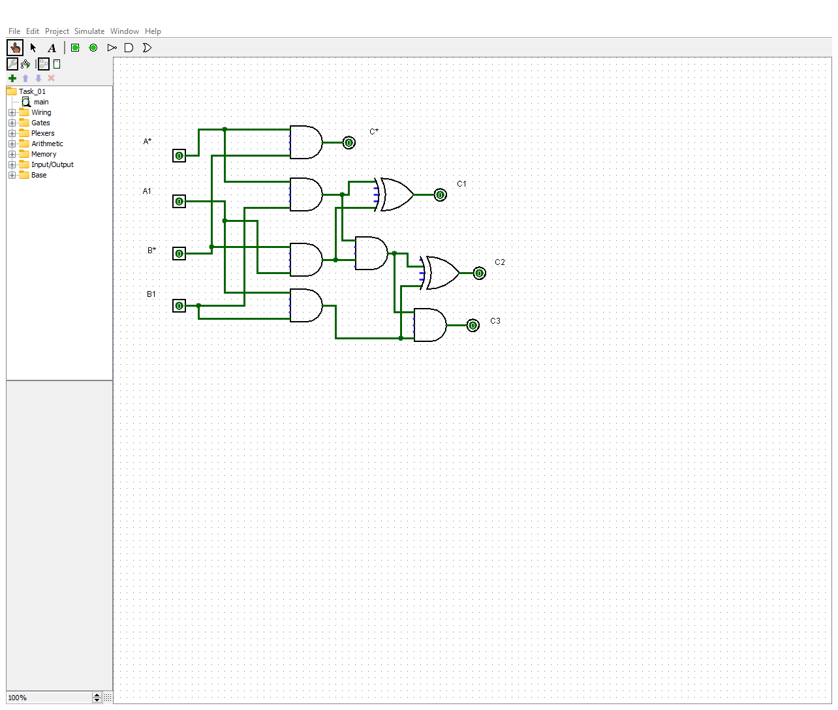

**Exercise # 2**

Design 3*3 Bit Binary Multiplier Circuit in Logisim/Logic Works.

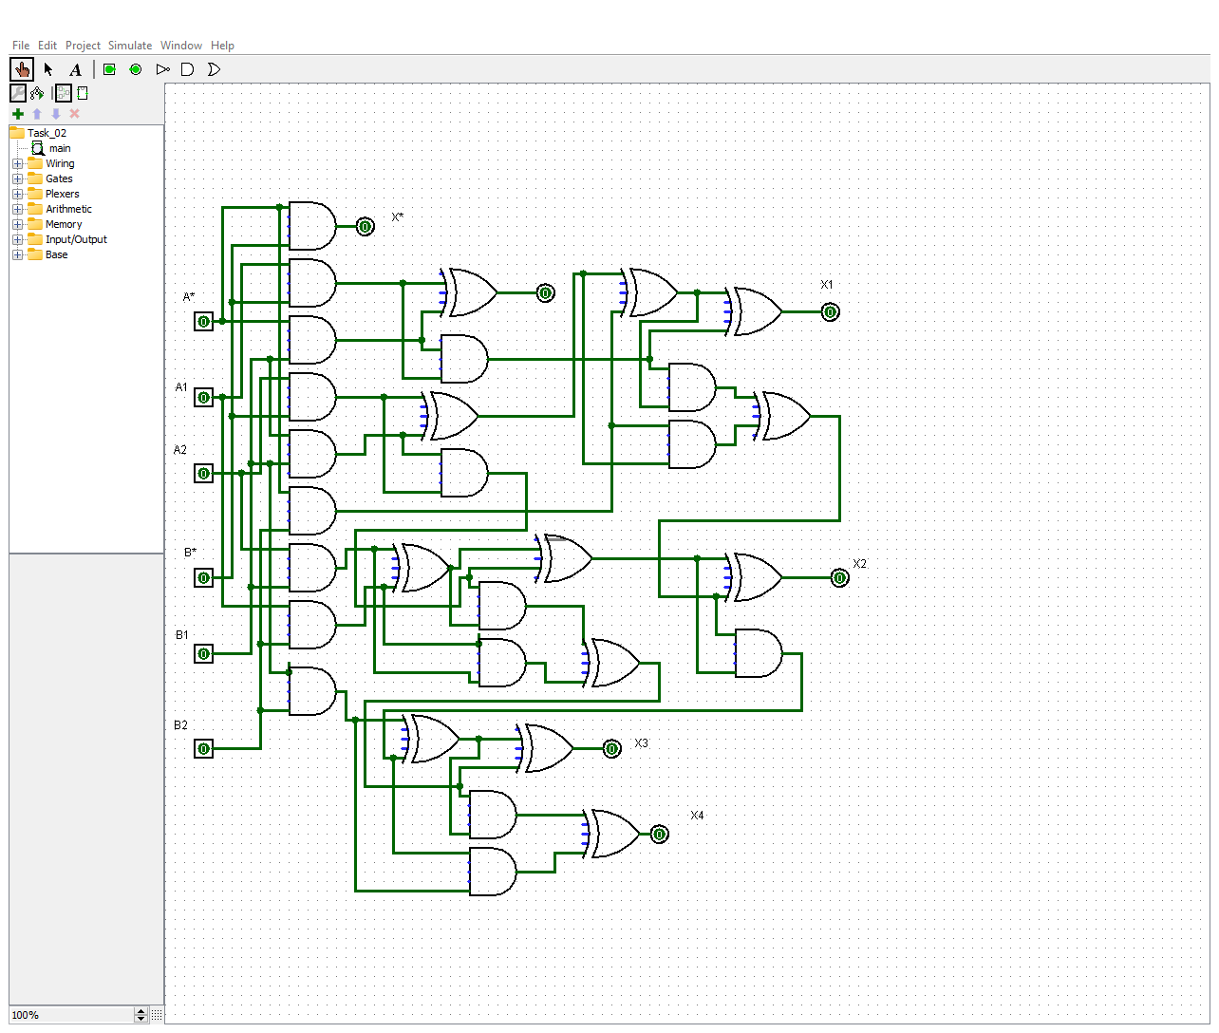

**Exercise # 3**

Design Full Adder Circuit in Logisim/Logic Works.

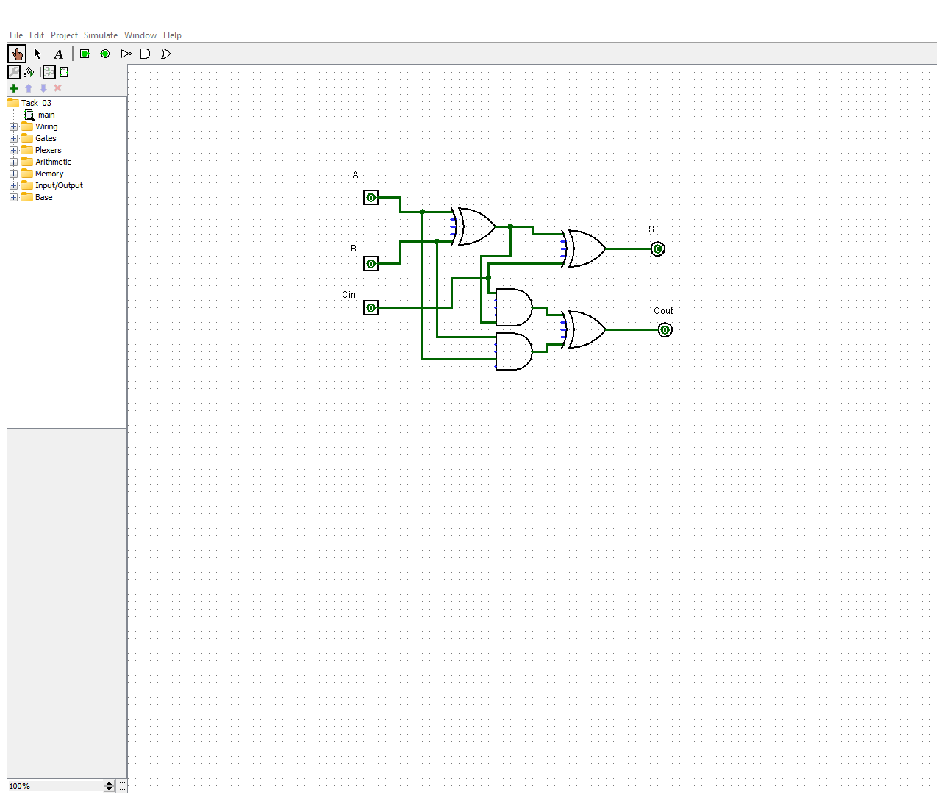

**Exercise # 4**

Design Full Subtractor Circuit in Logisim/Logic Works.

